World Building

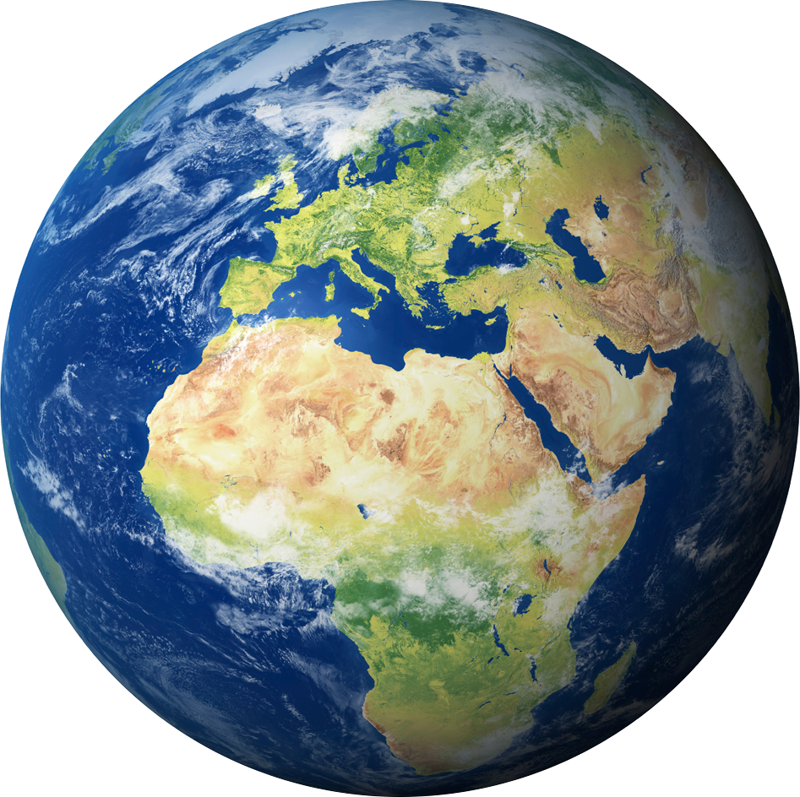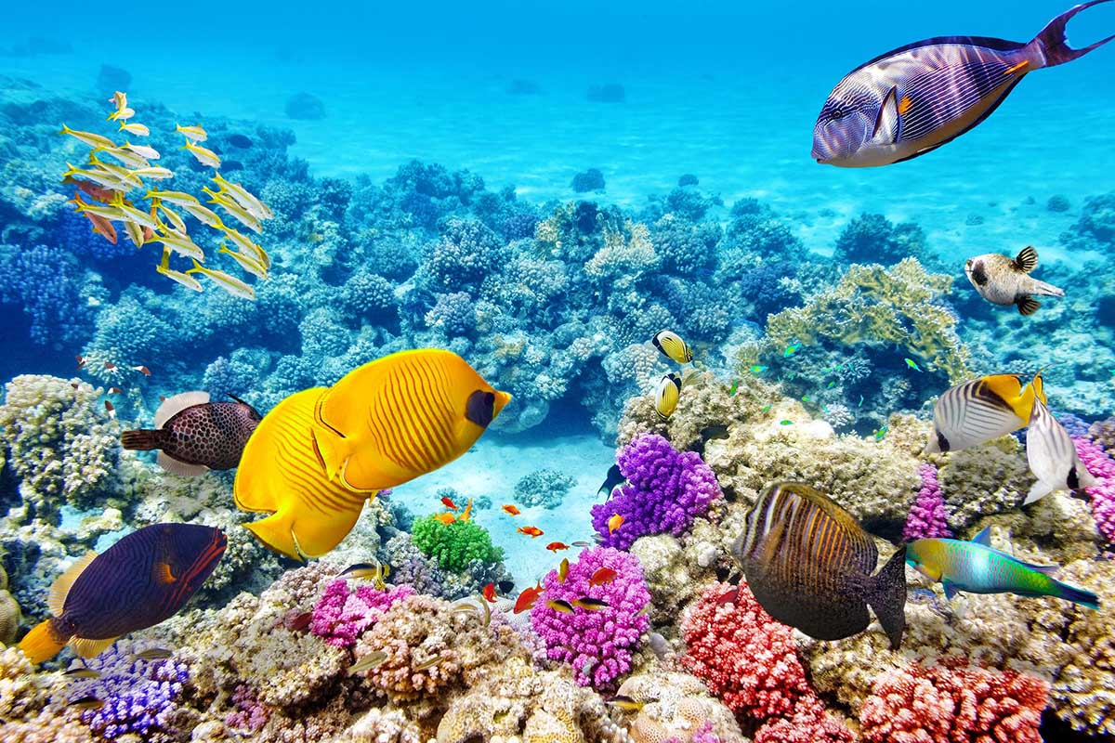

In what world does your story take place? Describe it (or draw it!) Some things to think about …

What is society like?
What animals/plants exist?
What is the weather like?
Is there magic? If so what are the rules of magic – how does it work (wands, spells, cooking …)?

Setting

The story setting is what the main character sees/senses. The setting can change throughout the story.

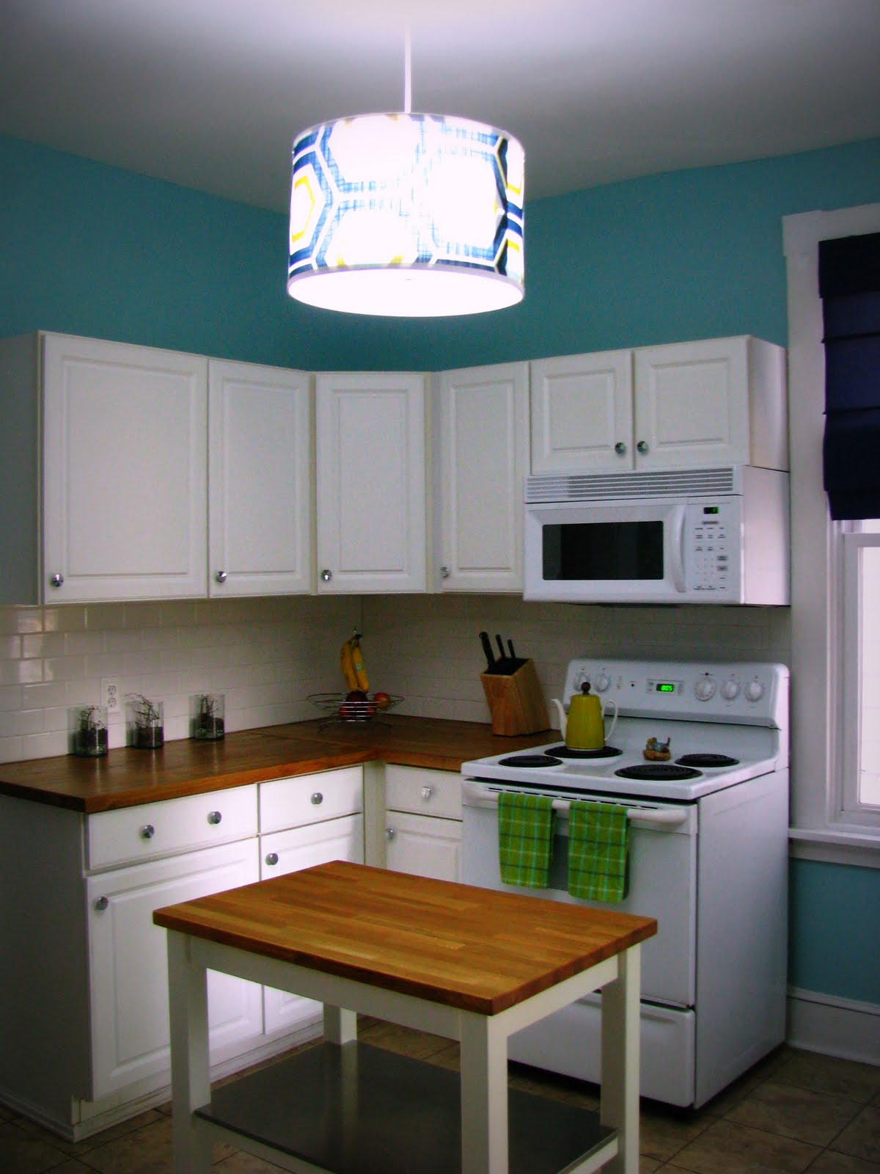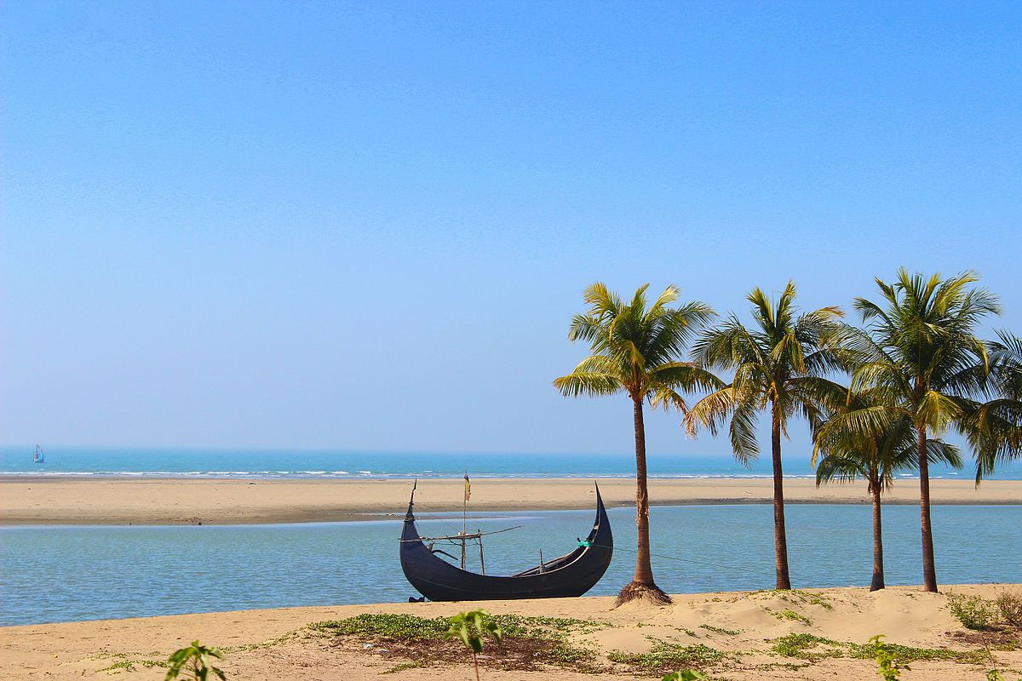

Where will you start your story? Describe it (or draw it!) Some things to think about …

What can the main character see?
What can they smell?
What can they feel/touch?
Can they taste anything?
What can they hear?
What is the overall feel of the place (cosy, spooky …)
What does the character like about the setting?
What do they NOT like?

